$$Type equation here.$$
MULTI-AXIAL LOADING: Generalised Hooke’s Law
So far, we have been discussing uni-axial loading. Now, consider an element of the material is subjected to axial normal stresses in three mutually perpendicular directions. Let the side of the cube be $a$. The normal stresses will change the dimensions of the cube. If the material is stresses within the linear elastic range, we can apply the principle of superposition. That is, the effect of each stress is considered separately and total deformation is the algebraic sum of the individual deformations. | 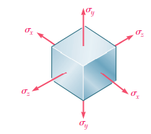
Only normal stresses will cause a change is dimension (or change in volume), shear stress will not. Shear stress will cause only a change in shape.
The strains produced by each normal stress in three mutually perpendicular directions are given in the table below.
 | Strain in the x-direction | Strain in the y-direction | Strain in the z-direction
Tensile stress in the x-direction, $σ_{xx}$ | $$\frac{σ_{xx}}{E}$$  (linear strain) | $$-ν\frac{σ_{xx}}{E}$$  (lateral strain) | $$-ν\frac{σ_{xx}}{E}$$  (lateral strain)
Tensile stress in the y-direction, $σ_{yy}$ | $$-ν\frac{σ_{yy}}{E}$$  (lateral strain) | $$\frac{σ_{yy}}{E}$$  (linear strain) | $$-ν\frac{σ_{yy}}{E}$$  (lateral strain)
Tensile stress in the z-direction, $σ_{zz}$ | $$-ν\frac{σ_{zz}}{E}$$  (lateral strain) | $$-ν\frac{σ_{zz}}{E}$$  (lateral strain) | $$\frac{σ_{zz}}{E}$$  (linear strain)

The net normal strain in the x-direction, $ε_{xx}=\frac{σ_{xx}}{E}-ν\frac{σ_{yy}}{E}-ν\frac{σ_{zz}}{E}$
The net normal strain in the y-direction, $ε_{yy}=\frac{σ_{yy}}{E}-ν\frac{σ_{xx}}{E}-ν\frac{σ_{zz}}{E}$
The net normal strain in the x-direction, $ε_{zz}=\frac{σ_{zz}}{E}-ν\frac{σ_{xx}}{E}-ν\frac{σ_{yy}}{E}$
The shear strains
$$ε_{xy}=\frac{γ_{xy}}{2}=\frac{τ_{xy}}{2G}=\frac{τ_{xy}}{2\frac{E}{2(1+ν)}}=\frac{τ_{xy}(1+ν)}{E} ≪≫ ε_{yz}=\frac{τ_{yz}(1+ν)}{E} ≪≫ ε_{zx}=\frac{τ_{zx}(1+ν)}{E}$$
This is known as generalised Hooke’s Law for multi-axial loading.
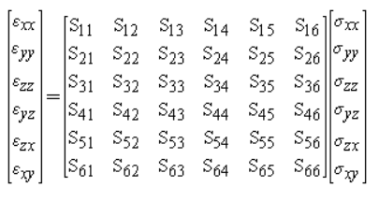
$$ε_{xz}$$
$$ε_{yz}$$
$$ε_{xy}$$
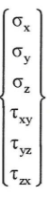
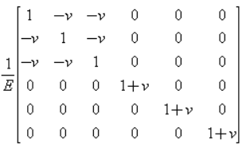

It is left as an exercise to the students to express the stresses in terms of the strain values as shown below.
$$σ_{xx}=\frac{νE}{(1+ν)(1-2ν)}\left(ε_{xx}+ε_{yy}+ε_{zz}\right)+\frac{E}{1+ν}ε_{xx}=λe+2Gε_{xx}$$

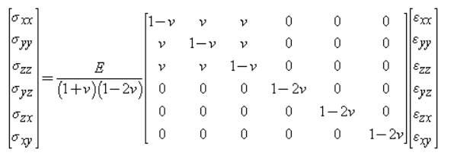
$$ε_{xz}$$
$$ε_{yz}$$
$$ε_{xy}$$


Due to the normal strains in the three mutually perpendicular directions, the dimensions of the cube$(a,a,a)$ will change to $(a+aε_{xx}, a+aε_{yy},a+aε_{zz})$.
The initial volume of the cube, $V=a^{3}$
The final volume of the cube,
$V^{'}=\left(a+aε_{xx}\right)\left( a+aε_{yy}\right)\left(a+aε_{zz}\right)=a^{3}(1+ε_{xx})(1+ε_{yy})(1+ε_{zz})$
$$=a^{3}\left\{1+\left(ε_{xx}+ε_{yy}+ε_{zz}\right)+\left(ε_{xx}ε_{yy}+ε_{yy}ε_{zz}+ε_{xx}ε_{zz}\right)+ε_{xx}ε_{yy}ε_{zz}\right\}$$
Since the strain values are very small, their products are still smaller and hence they can be neglected.
$$V^{'}=a^{3}\left\{1+\left(ε_{xx}+ε_{yy}+ε_{zz}\right)\right\}$$
The change in volume, $ΔV=V^{'}-V=a^{3}\left(ε_{xx}+ε_{yy}+ε_{zz}\right)$
$$The volumetric strain (Dilatation, e)=\frac{Change in volume}{Original volumne}=\frac{ΔV}{V}=\left(ε_{xx}+ε_{yy}+ε_{zz}\right)$$
$$e=\left(\frac{σ_{xx}}{E}-ν\frac{σ_{yy}}{E}-ν\frac{σ_{zz}}{E}\right)+\left(\frac{σ_{yy}}{E}-ν\frac{σ_{xx}}{E}-ν\frac{σ_{zz}}{E}\right)+\left(\frac{σ_{zz}}{E}-ν\frac{σ_{xx}}{E}-ν\frac{σ_{yy}}{E}\right)$$

$$e=\frac{σ_{xx}+σ_{yy}+σ_{zz}}{E}-\frac{2ν}{E}\left(σ_{xx}+σ_{yy}+σ_{zz}\right)=\left(σ_{xx}+σ_{yy}+σ_{zz}\right)\left(\frac{1-2ν}{E}\right)$$
If $σ_{xx}=σ_{yy}=σ_{zz}=σ$ (Spherical stress or Hydrostatic stress)
$$e=3σ\left(\frac{1-2ν}{E}\right)$$
$$\frac{σ}{e}=\frac{E}{3(1-2ν)}$$
The ratio of spherical stress to volumetric strain(dilatation) is known as Bulk Modulus $(K)$
$$K=\frac{E}{3(1-2ν)}$$

A positive $σ$ (tensile stress) will produce a positive dilatation (increase in volume) only if
$$\left(1-2ν\right)>0 ≪≫ ν<\frac{1}{2}$$
For any engineering material, the Poisson’s ratio varies between $0$ and $0.5.$

Example 1  The steel block shown is subjected to a uniform pressure on all its faces. Knowing that the change in length of edge $AB$ is $-3.05×{10}^{-3} cm$, determine (a) the change in length of the other two edges, (b) the pressure $p$ applied to the faces of the block. (c) the change in volume of the block. Assume $E=200 GPa$ and $ν=0.29$ | 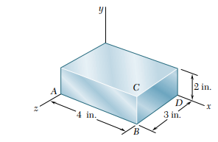  7.5 cm  5 cm  10cm
Let $p$ be the pressure (compressive stress) acting on all the sides.
$$ε_{xx}=\frac{σ_{xx}}{E}-ν\frac{σ_{yy}}{E}-ν\frac{σ_{zz}}{E}=\frac{-p}{E}+ν\frac{p}{E}+ν\frac{p}{E}=-\frac{p}{E}(1-2ν)$$
$$ε_{yy}=\frac{σ_{yy}}{E}-ν\frac{σ_{xx}}{E}-ν\frac{σ_{zz}}{E}=\frac{-p}{E}+ν\frac{p}{E}+ν\frac{p}{E}=-\frac{p}{E}(1-2ν)$$
$$ε_{zz}=\frac{σ_{zz}}{E}-ν\frac{σ_{xx}}{E}-ν\frac{σ_{yy}}{E}=\frac{-p}{E}+ν\frac{p}{E}+ν\frac{p}{E}=-\frac{p}{E}(1-2ν)$$
$$ε_{xx}=\frac{δ_{AB}}{L_{AB}}=\frac{-3.05×{10}^{-3} cm}{10 cm}=-0.305×{10}^{-3}$$
$$∴ -0.305×{10}^{-3}=-\frac{p}{E}\left(1-2ν\right)=-\frac{p}{200×{10}^{9}}\left(1-2×0.29\right) ≪≫ p=145.2×{10}^{6} Pa$$
$$ε_{yy}=ε_{zz}=-\frac{p}{E}\left(1-2ν\right)=-0.305×{10}^{-3}$$
$$δ_{BC}=L_{BC}×ε_{yy}=-1.525×{10}^{-3} cm$$
$$δ_{BD}=L_{BD}×ε_{zz}=-2.2875×{10}^{-3} cm$$
The bulk modulus, $K=\frac{E}{3(1-2ν)}=\frac{200×{10}^{9}}{3(1-2×0.29)}=158.7×{10}^{9} Pa$
$$K=\frac{hydrostatic stress}{dilatation}=\frac{-145.2×{10}^{6}}{e} ≪≫ e=-9.1476×{10}^{-4}$$
$$V=10 cm×7.5 cm×5 cm=375 {cm}^{3}$$
$$\frac{ΔV}{V}=-9.1476×{10}^{-4} ≪≫ ΔV=-0.3430 {cm}^{3}$$

Example 2  A circle of diameter $d=225 mm$ is scribed on an unstressed aluminium plate of thickness $t=20 mm$. Forces acting in the plane of the plate later cause normal stress $σ_{xx}=83 MPa$ and $σ_{zz}=138 MPa$. For $E=70 GPa$ and $ν=0.33$, determine the change in (a) the diameter AB, and CD, (b) the thickness of the plate, (d) the volume of the plate. | 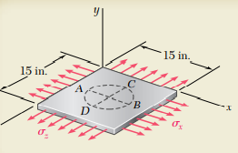  380mm  380mm
The original volume of the plate, $V=0.38m×0.38m×0.02m=2.888×{10}^{-3} m^{3}$

 | Strain in the x-direction | Strain in the y-direction | Strain in the z-direction
Stress along x-axis  $$σ_{xx}=83 MPa$$ | $$\frac{σ_{xx}}{E}=\frac{83×{10}^{6}}{70×{10}^{9}}=1.186×{10}^{-3}$$  (linear strain) | $$-ν\frac{σ_{xx}}{E}=-0.344×{10}^{-3}$$  (lateral strain) | $$-ν\frac{σ_{xx}}{E}=-0.344×{10}^{-3}$$  (lateral strain)
Stress along x-axis  $$σ_{xx}=138 MPa$$ | $$-ν\frac{σ_{zz}}{E}=-0.651×{10}^{-3}$$  (lateral strain) | $$-ν\frac{σ_{zz}}{E}=-0.651×{10}^{-3}$$  (lateral strain) | $$\frac{σ_{zz}}{E}=\frac{138×{10}^{6}}{70×{10}^{9}}=1.97×{10}^{-3}$$  (linear strain)
 | $$ε_{xx}=0.535×{10}^{-3}$$ | $$ε_{yy}=-0.995×{10}^{-3}$$ | $$ε_{zz}=1.626×{10}^{-3}$$
Change in the diameter AB, $δ_{AB}=ε_{xx}×\left(AB\right)=0.535×{10}^{-3}×225mm=+0.1204 mm$
Change in the diameter CD, $δ_{CD}=ε_{zz}×\left(CD\right)=1.626×{10}^{-3}×225mm=+0.3659 mm$
Change in the thickness, $δ_{t}=ε_{yy}×\left(t\right)=-0.995×{10}^{-3}×20mm=-0.0199 mm$
Final length of the plate, $L_{x}=380\left(1+0.535×{10}^{-3}\right)=380.2033 mm$
Final breadth of the plate, $L_{z}=380\left(1+1.626×{10}^{-3}\right)=380.6179 mm$
Final thickness of the plate, $L_{y}=20-0.0199=19.9801 mm$
New volume of the plate, $V^{'}=380.2033 mm×380.6179 mm×19.9801 mm=2.891×{10}^{-3} m^{3}$

#Exercise 1  An aluminium plate $\left(E=74 GPa,ν=0.33\right)$is subjected to a centric axial load that causes a normal stress $σ$. Knowing that, before loading, a line of slope $2:1$ is sribed on the plate, determine the slope of the line when $σ=125 MPa.$ | 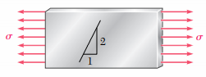
#Exercise 2  The block shown is made of a magnesium alloy $\left(E=45 GPa,ν=0.35\right)$. Knowing that $σ_{x}=-180 MPa$, determine (a) the magnitude of $σ_{y}$ for which the change in the height of the block will be zero, (b) the corresponding change in the area of the face ABCD, (c) the change in volume of the block. | 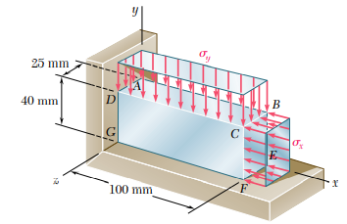

Reference:
- Mechanics of Materials, 2/e, J. M. Gere & S. P.Timoshenko, CBS Publishers.
- Mechanics of Materials, 6/e, F.P. Beer & E. R. Johnston, McGraw Hill
- Engineering Mechanics of Solids, 2/e, E. P. Popov, Pearson Education Asia.
- Mechanics of Materials, 9/e, R. C. Hibbeler, Prentice Hall.

